

**SKILL JOURNAL**

Enrollment Number – 2019BTCS088 Year of Enrollment – 2019-2023

Name of the Student – YASH GUPTA

School of COMPUTER SCIENCE & INFORMATION TECHNOLOGY

Program – B. TECH

Specialization/ Branch – CS&IT

Semester – 3rd Section – B2 Branch – CS&IT

Paper Code – BTCS04CFB2 Name of Paper – Statistics-II

Faculty-In-Charge – DEVENDRA CHOUHAN SIR

CERTIFICATE

THE SKILL EXPERIMENTS

ENTERED IN THIS JOURNAL HAVE BEEN SATISFACTORY PERFORMED BY

ENROLLMENT NO - 2019BTCS088 MR/MS­­­­­­­­­­­­­­­­­­­­ YASH GUPTA

STUDYING IN PROGRAM B. TECH BRANCH CS&IT IN

SCHOOL OF COMPUTER SCIENCE & INFORMATION TECHNOLOGY

DURING SEMESTER 3rd OF ACADEMIC YEAR 2020-2021

_______________________

( )

Date: _________________

INDEX

|  |  |  |  |  |
| --- | --- | --- | --- | --- |
| S.NO | Title of Skill Activity | Date of Allocation | Date of Submission | Sign of Faculty |
| 1. | Concept of Graphical Representation of data with MATLAB | 10/06/2021 | 12/06/2021 |  |
|  |  |  |  |  |
| 2. | Concept of Mean with MATLAB | 15/06/2021 | 16/06/2021 |  |
|  |  |  |  |  |
| 3. | Concept of Median with MATLAB | 15/06/2021 | 16/06/2021 |  |
|  |  |  |  |  |
| 4. | Concept of Mode with MATLAB | 15/06/2021 | 25/06/2021 |  |
|  |  |  |  |  |
| 5. | Concept of Standard Deviation with MATLAB | 15/06/2021 | 17/06/2021 |  |
|  |  |  |  |  |
|  |  |  |  |  |
|  |  |  |  |  |
|  |  |  |  |  |
|  |  |  |  |  |
|  |  |  |  |  |
|  |  |  |  |  |
|  |  |  |  |  |
|  |  |  |  |  |
|  |  |  |  |  |
|  |  |  |  |  |
|  |  |  |  |  |
|  |  |  |  |  |
|  |  |  |  |  |

SKILL ACTIVITIY NO: 1  
(Concept of Graphical Representation of Data with MATLAB)

Date: 12th June 2021

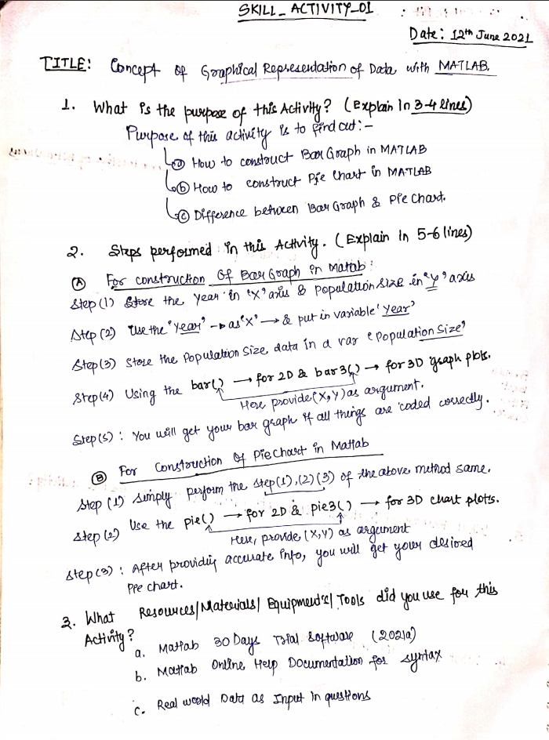

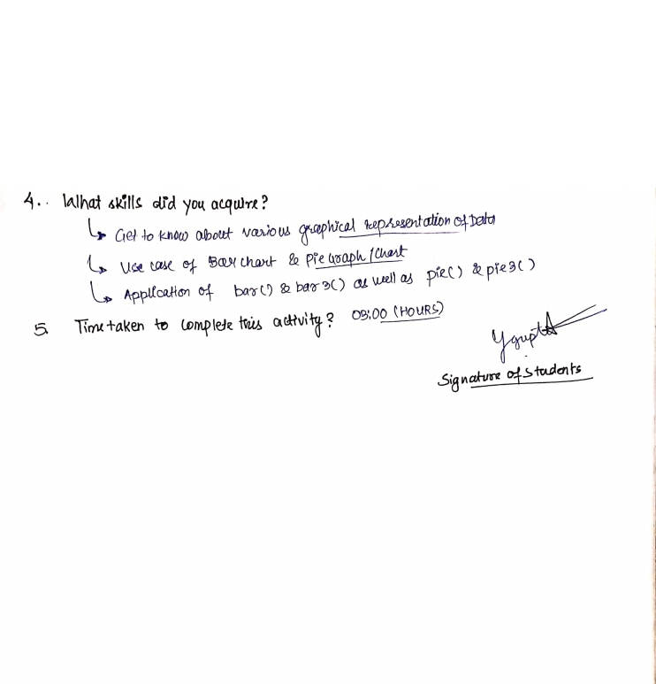

**(To be filled by Faculty)**

|  |  |  |
| --- | --- | --- |
| Sr. No. | Skill /Competencies | (Achieved / Not Achieved)  (Yes / No) |
|  |  |  |
|  |  |  |
|  |  |  |
|  |  |  |

Remarks :

Total mark ___________________________out of 10.

Signature of Faculty

Date: _________________

**Details of Activity:**

1. **Question 1: Example of Bar Graph Problem**

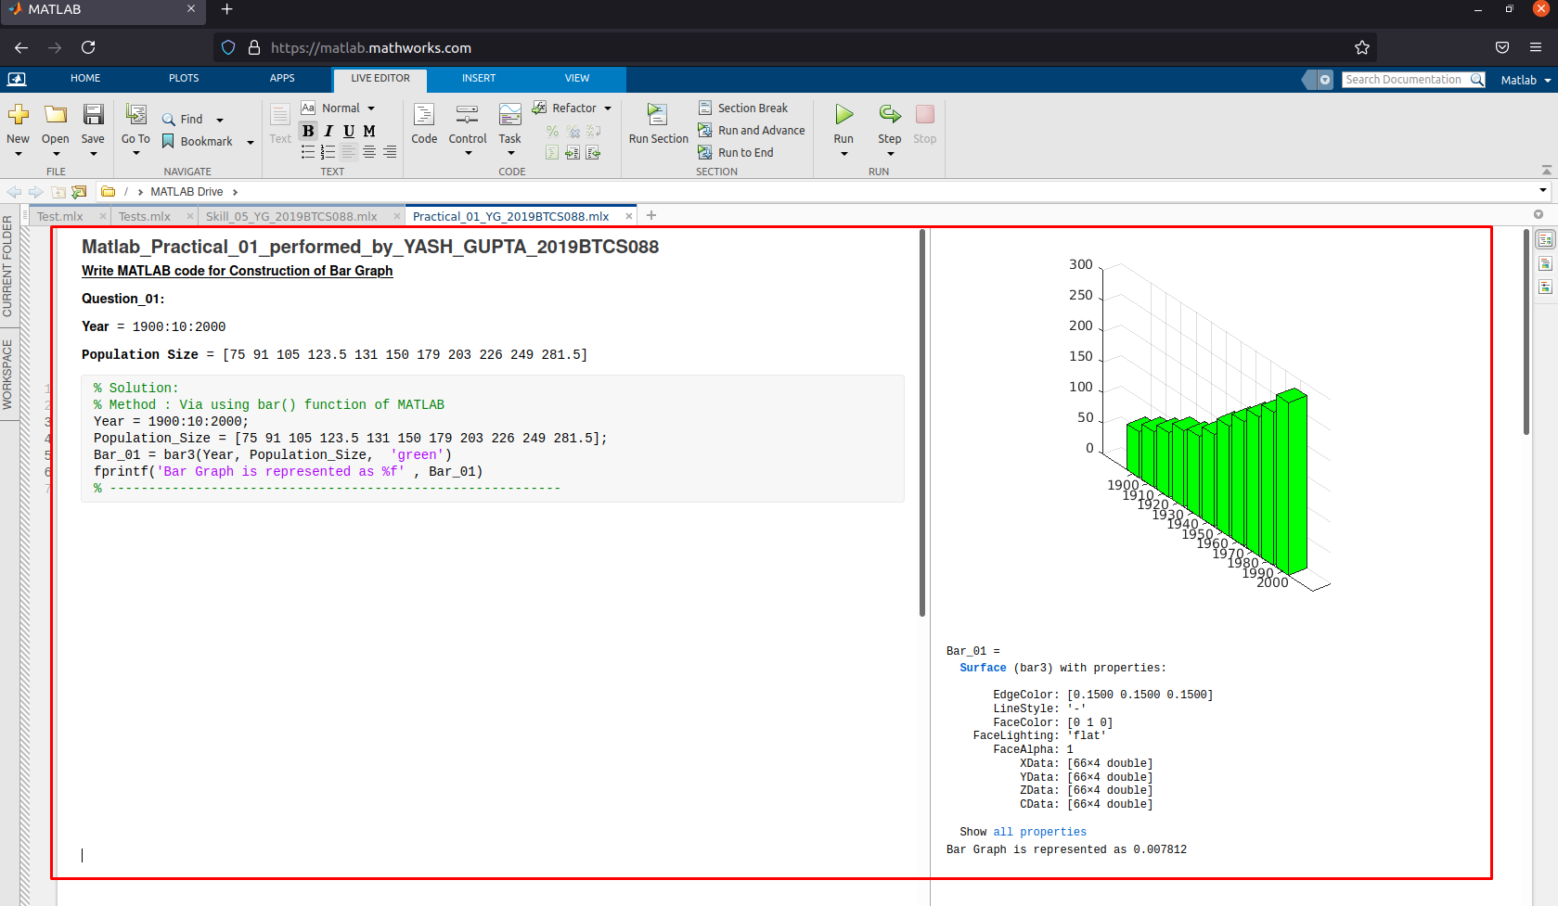

1. **Question 2: Example of Bar Graph Problem**

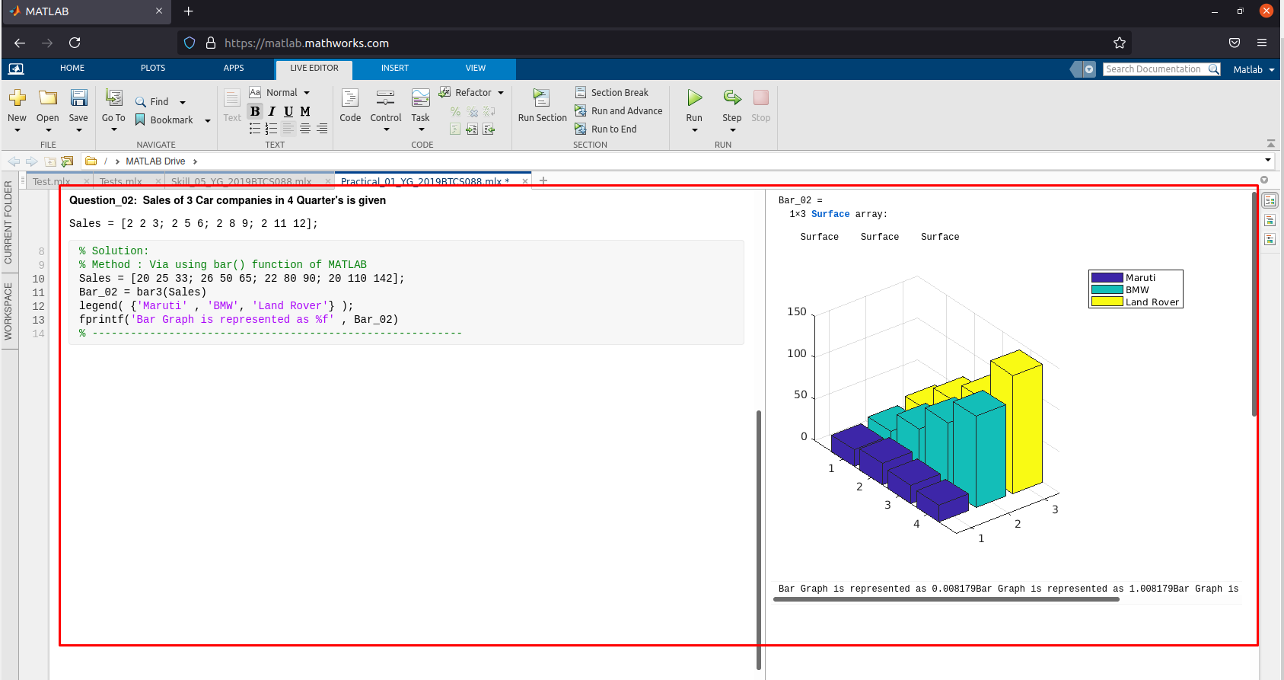

1. **Question 3: Example of Bar Graph Problem**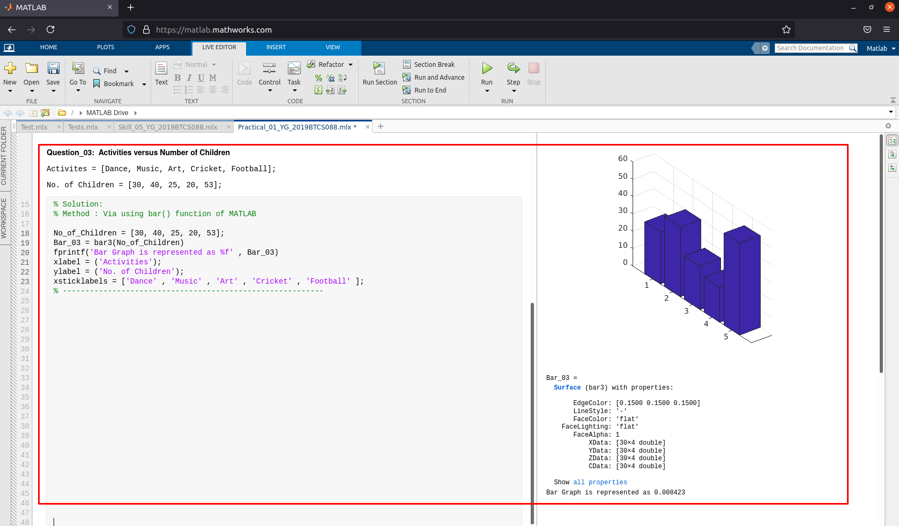
2. **Question 1: Example of Pie Chart Problem**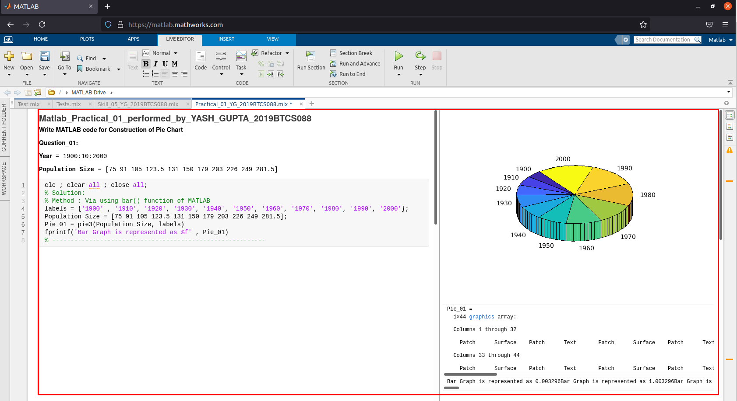
3. **Question 2: Example of Pie Chart**

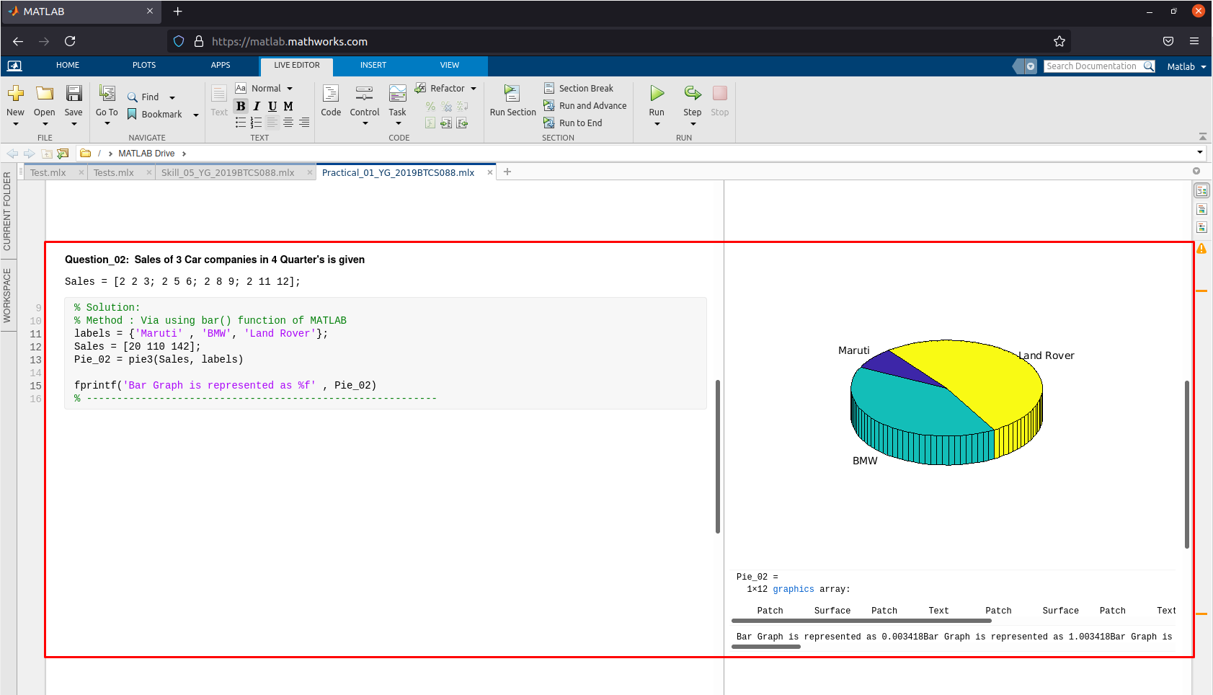

1. **Question 3: Example of Pie Chart**

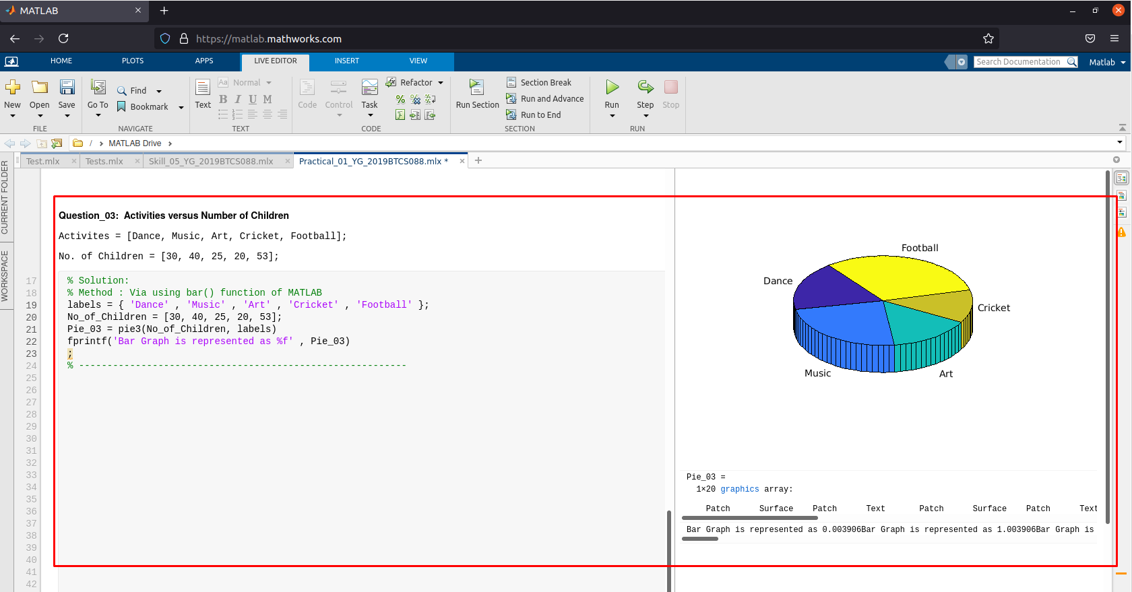

SKILL ACTIVITIY NO: 2  
(Concept of Mean with MATLAB)

Date: 16th June 2021

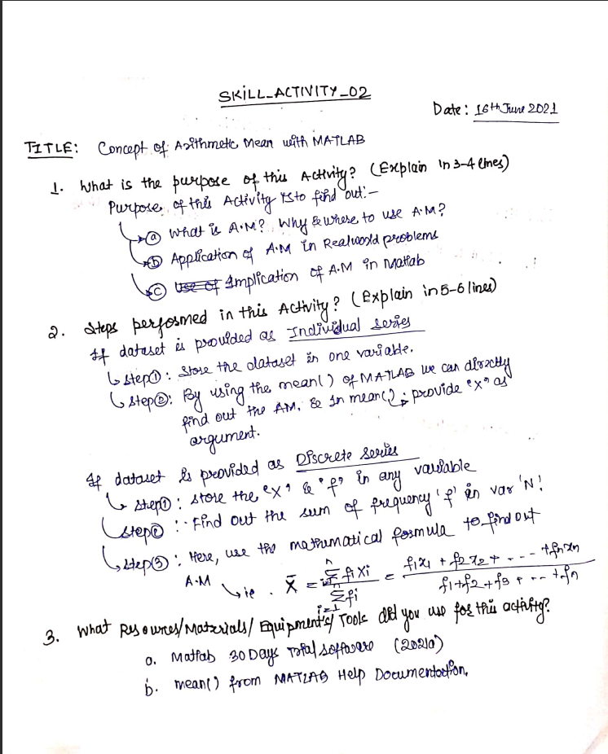

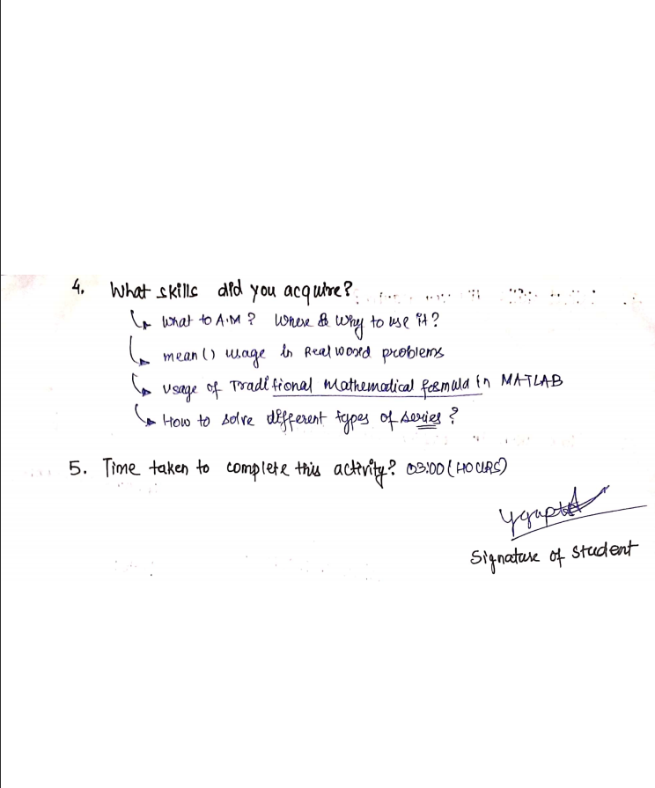

**(To be filled by Faculty)**

|  |  |  |
| --- | --- | --- |
| Sr. No. | Skill /Competencies | (Achieved / Not Achieved)  (Yes / No) |
|  |  |  |
|  |  |  |
|  |  |  |
|  |  |  |

Remarks :

Total mark ___________________________out of 10.

Signature of Faculty

Date: _________________

**Details of the Activity:**

**A. Example 1: Arithmetic Mean for Individual Series Problem.**

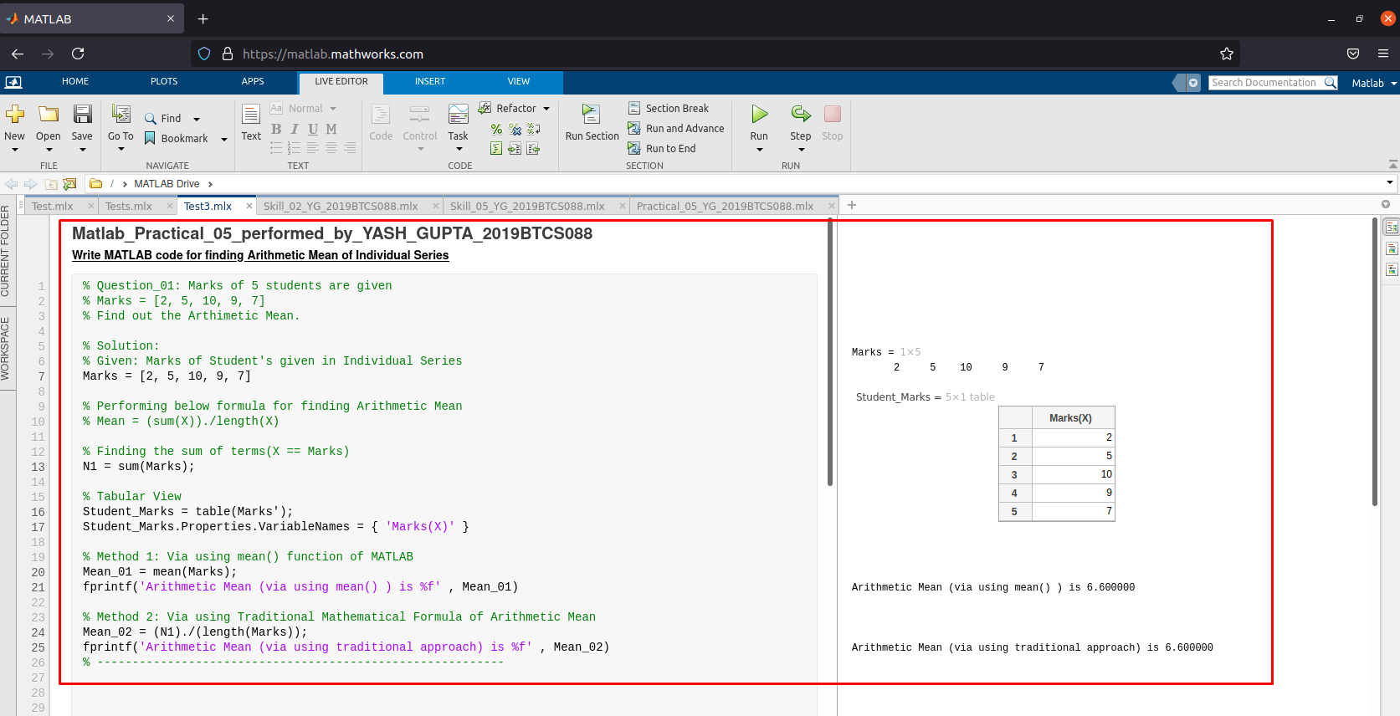

**D. Example 2: Arithmetic Mean for Discrete Series Problem.**

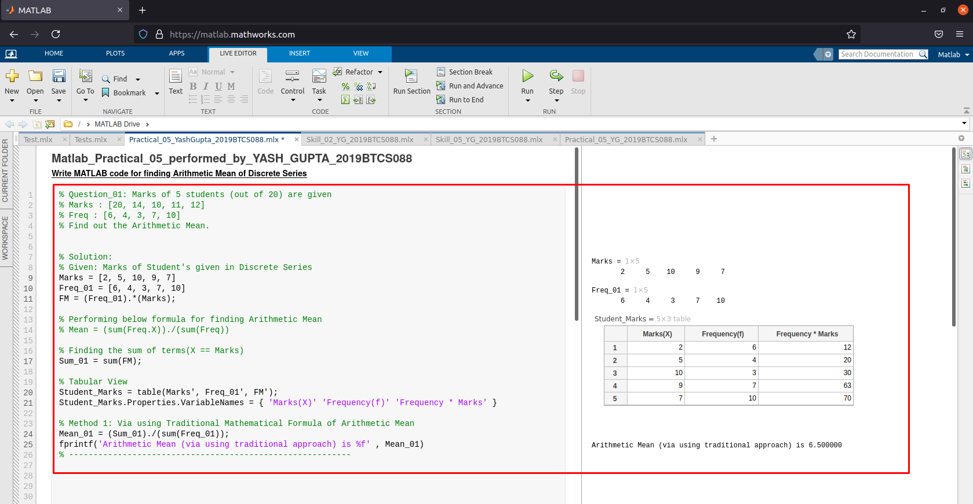 **-------------------------------------------------------------------------------------------------------------------------------------**

SKILL ACTIVITIY NO: 3  
(Concept of Median with MATLAB)

Date: 15th June 2021

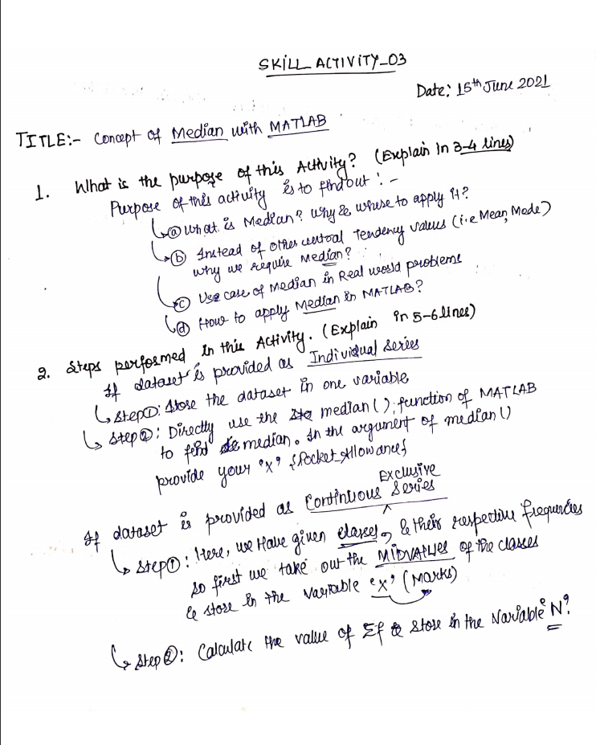

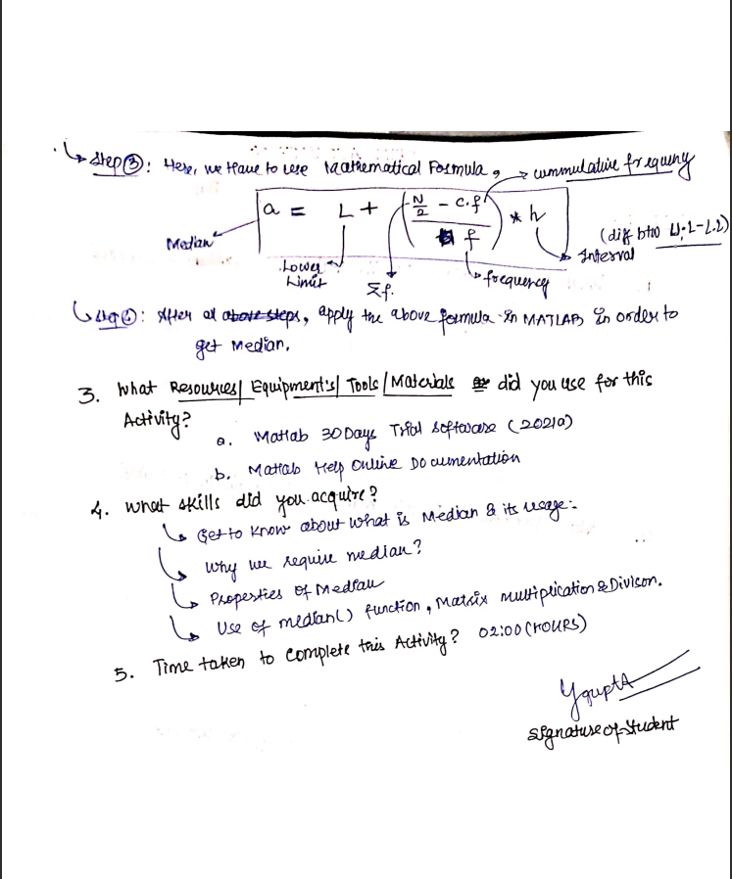

**(To be filled by Faculty)**

|  |  |  |
| --- | --- | --- |
| Sr. No. | Skill /Competencies | (Achieved / Not Achieved)  (Yes / No) |
|  |  |  |
|  |  |  |
|  |  |  |
|  |  |  |

Remarks :

Total mark ___________________________out of 10.

Signature of Faculty

Date: _________________

**Details of the Activity:**

**A. Example 1: Median for Individual Series Problem.**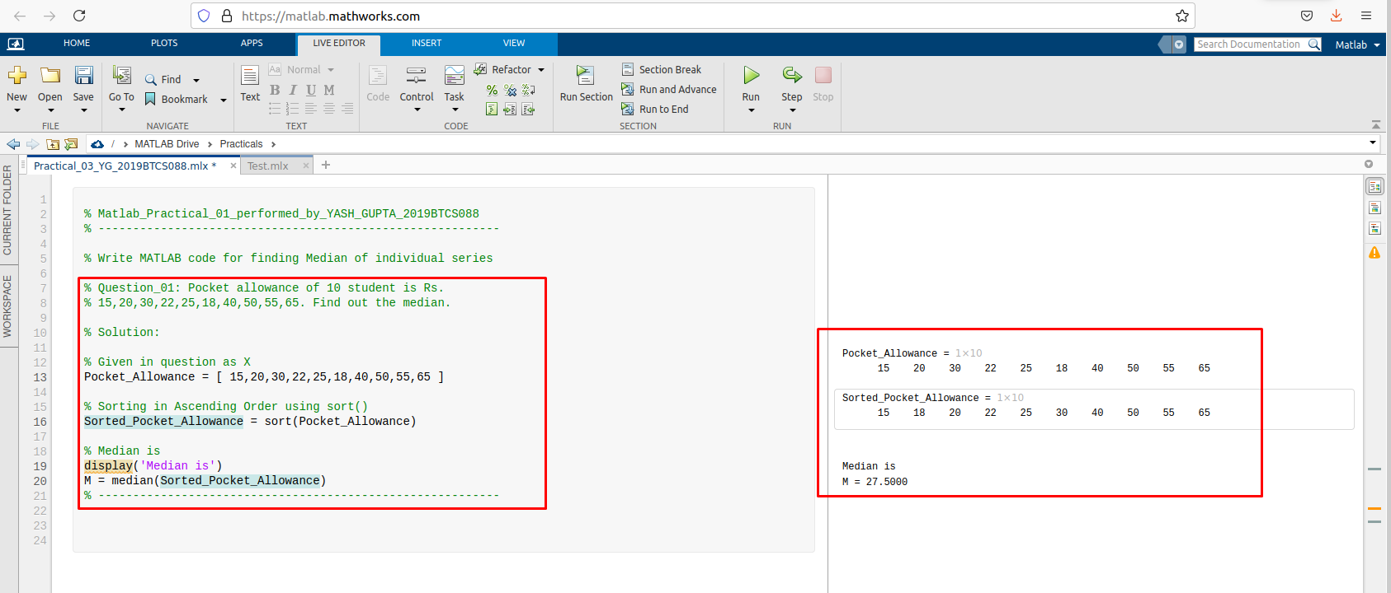

**B. Example 2: Median for Continuous Series Problem.**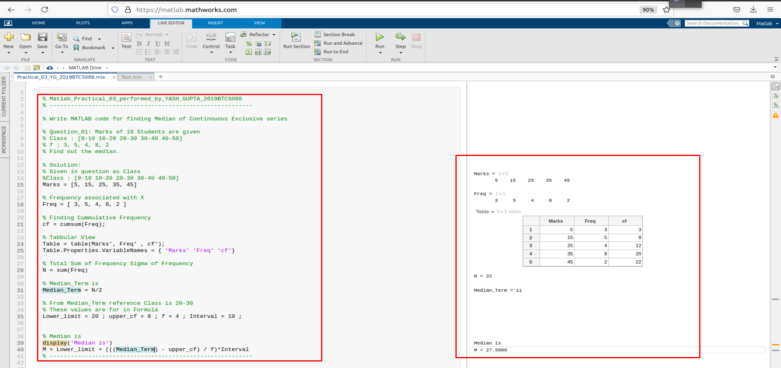

SKILL ACTIVITIY NO: 4  
(Concept of Mode with MATLAB)

Date: 25th June 2021

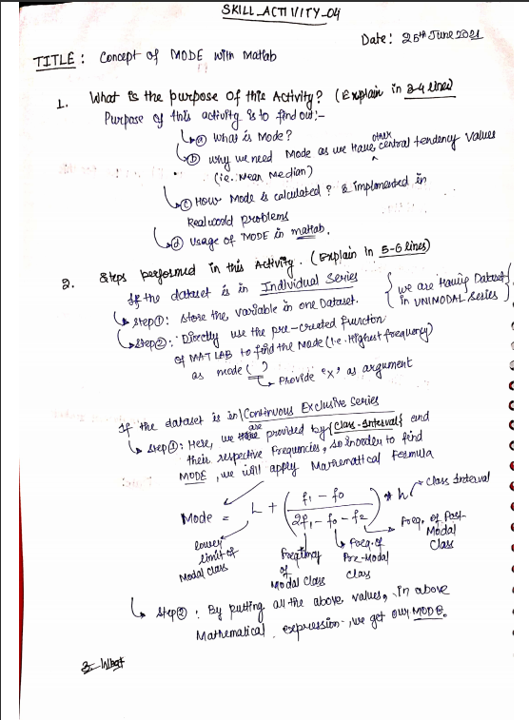

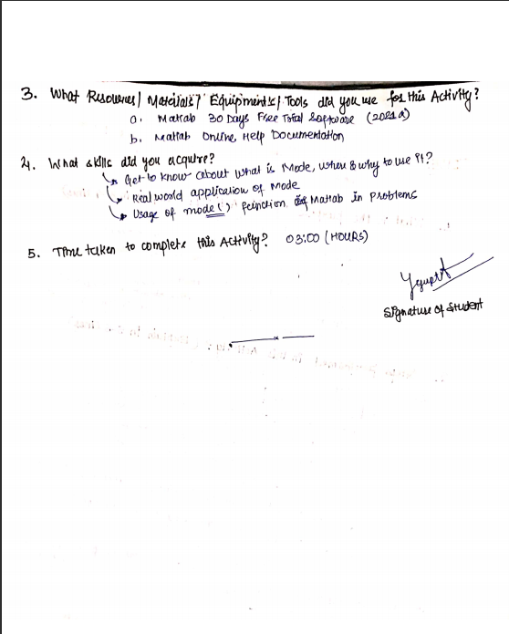

**(To be filled by Faculty)**

|  |  |  |
| --- | --- | --- |
| Sr. No. | Skill /Competencies | (Achieved / Not Achieved)  (Yes / No) |
|  |  |  |
|  |  |  |
|  |  |  |
|  |  |  |

Remarks :

Total mark ___________________________out of 10.

Signature of Faculty

Date: _________________

**Details of the Activity:**

1. **Example 1: Mode for Individual Series Problem.**

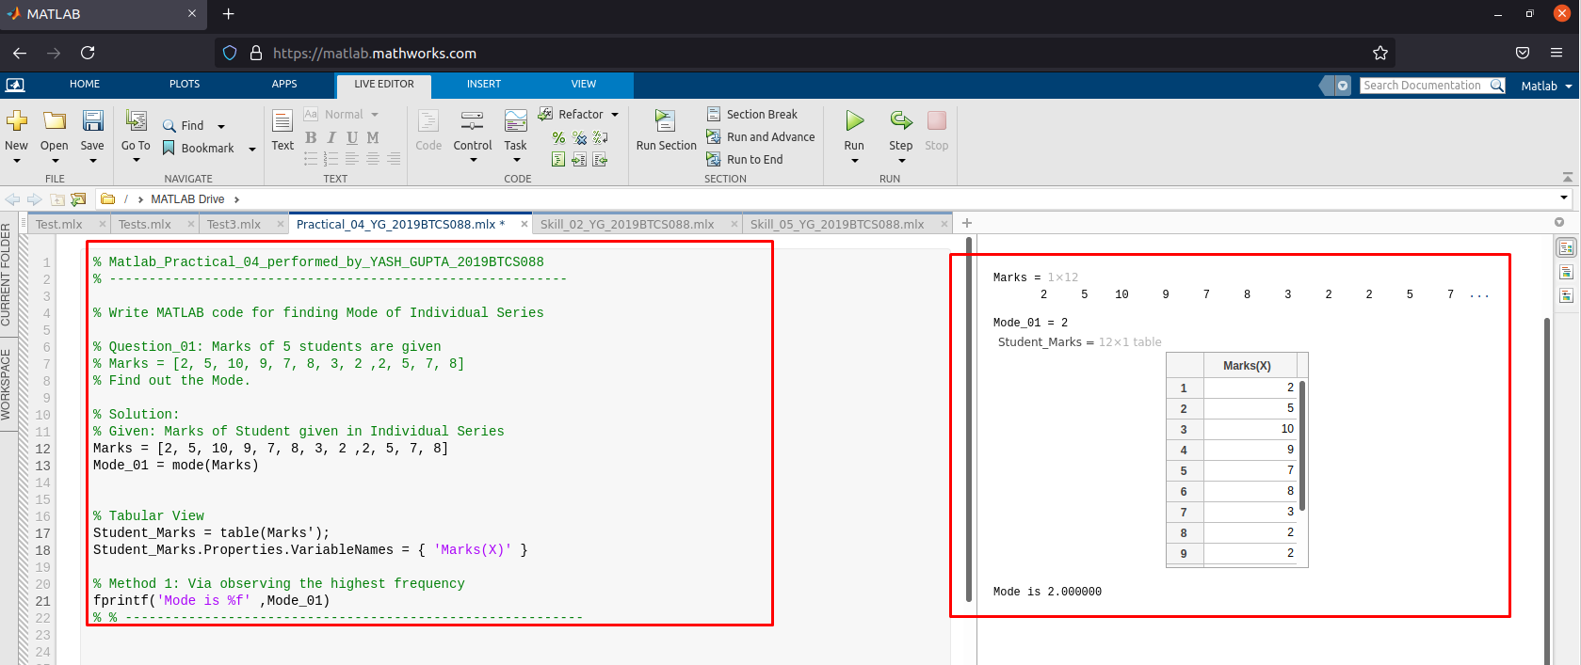

1. **Example 2: Mode for Continuous Series Problem.**

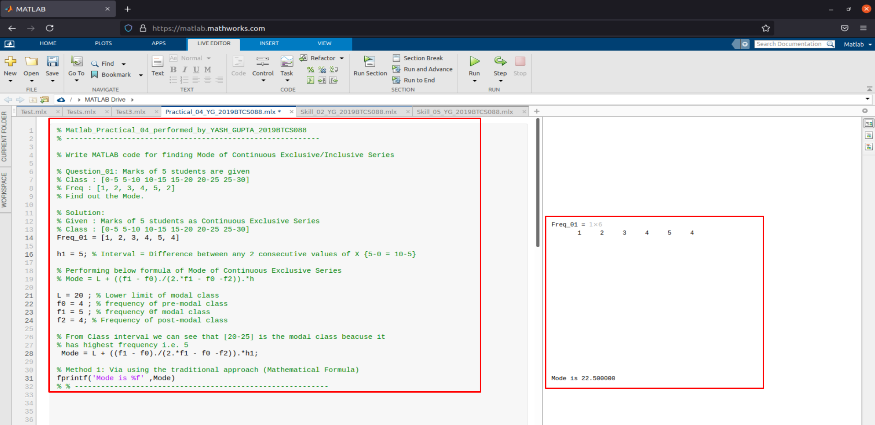

SKILL ACTIVITIY NO: 5  
(Concept of Standard Deviation with MATLAB)

Date: 17th June-2021

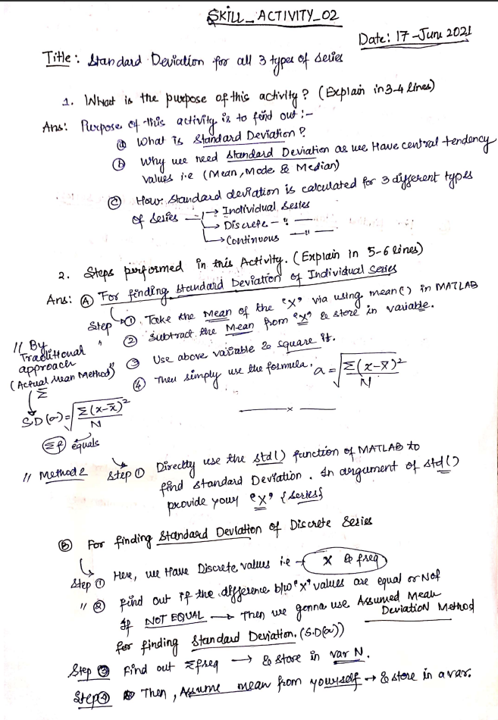

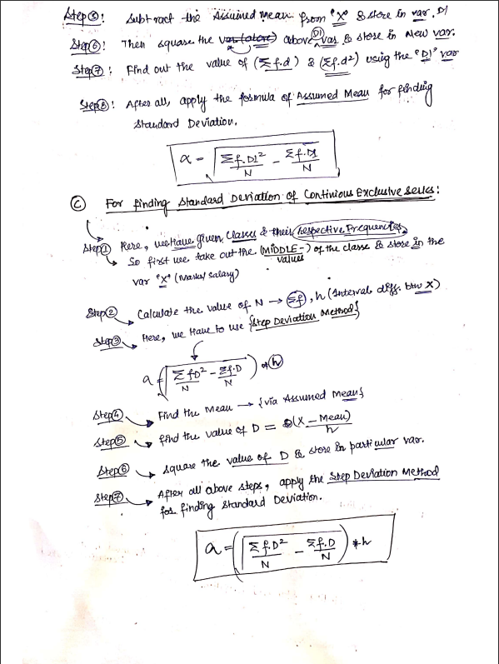

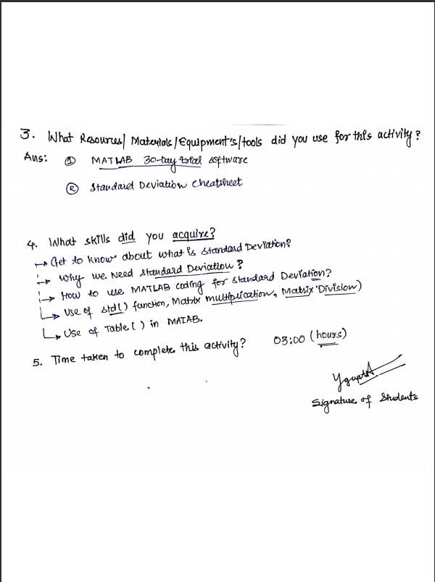

**(To be filled by Faculty)**

|  |  |  |
| --- | --- | --- |
| Sr. No. | Skill /Competencies | (Achieved / Not Achieved)  (Yes / No) |
|  |  |  |
|  |  |  |
|  |  |  |
|  |  |  |

Remarks :

Total mark ___________________________out of 10.

Signature of Faculty

Date: _________________

**Details of the Activity:  
  
A. Example 1: Standard Deviation for Individual Series Problem.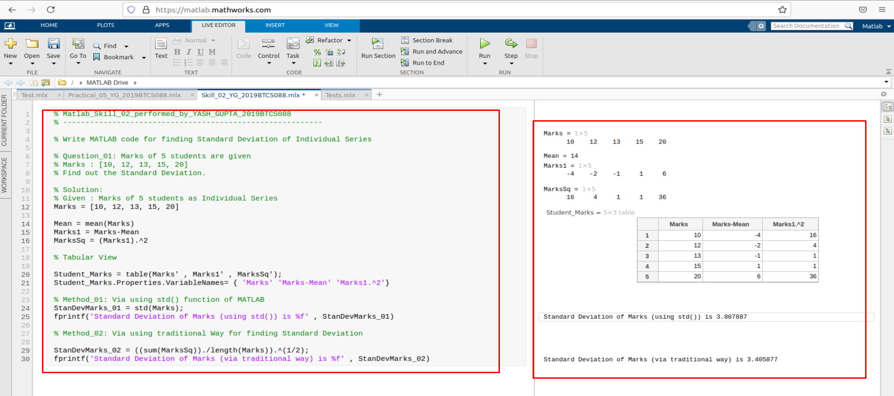 B. Example 1: Standard Deviation for Continuous Series Problem.**

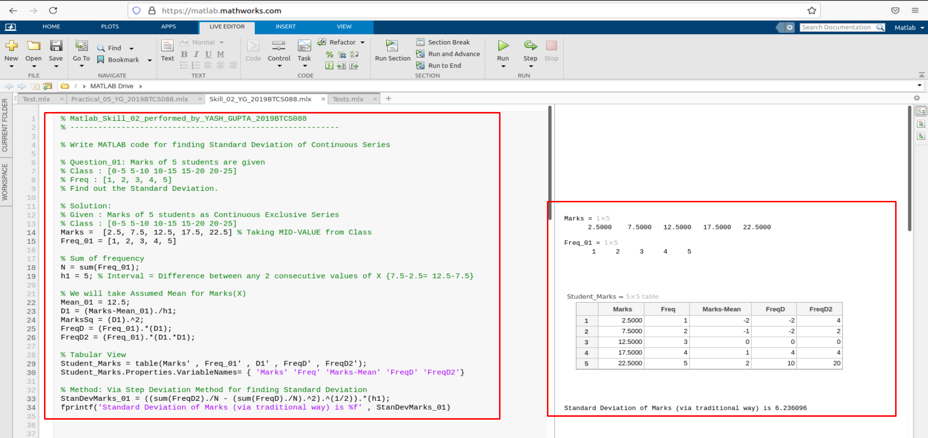

**C. Example 1: Standard Deviation for Discrete Series Problem.**